

COLLEGE CODE – 0001
COLLEGE NAME – COLLEGE OF ENGINEERING GUINDY
DEPARTMENT - COMPUTER SCIENCE ENGINEERING
STUDENT NM-ID - 6399E92F09068B78D4A44CBF0A1D13D6
ROLL NO - 2023103541
DATE – 30/09/2025

Completed the project named as
Phase – 1
Problem Understanding & Requirements
NAME : LOGIN AUTHENTICATION SYSTEM

SUBMITTED BY,

NAME - VIJAY ANANDAN J M
MOBILE NO – 7871648764

LOGIN AUTHENTICATION SYSTEM -
PROBLEM UNDERSTANDING & REQUIREMENTS

PROBLEM STATEMENT :

Many applications face security and accessibility issues because users do not have a proper authentication mechanism. Without a secure login system, unauthorized users may gain access to sensitive information, and users may experience difficulties in account creation, login, or password recovery. Additionally, limiting login methods to only email or password can reduce convenience for users.

SOLUTION :

The Login Authentication System addresses these issues by providing a secure and user-friendly interface that allows users to register and log in using multiple authentication methods, including email/password, mobile/OTP.

USERS & STAKEHOLDERS :

Users:
• End users who will use the system to register, log in, and access application services.
• Example: Students, employees, or customers.
Stakeholders:
• Project Owner: Oversees the project development, ensures it meets requirements, and approves deliverables.
• Frontend Developers: Implement the user interface, handle form validation, and ensure smooth user interactions.
• Backend Developers: Develop APIs for authentication, manage user data, and ensure secure credential storage.
• Security Team: Ensures the system is secure and protects user data against unauthorized access.

REQUIREMENTS :

Functional Requirements:
• User registration with email, mobile number, or social account.
• User login using credentials (email/password, mobile/OTP, or social login).
• Form validations (email format, mobile number format, password strength).
• Display error messages for invalid login or registration attempts.
• Password reset functionality via email or mobile.
• “Remember Me” option to keep users logged in.

Non-Functional Requirements:
• Responsive design for desktop and mobile devices.
• Fast loading and smooth user interface interactions.
• Secure handling of user credentials on the frontend (e.g., masking passwords).
• Real-time feedback for form inputs and login attempts.

USER STORIES:

• As a new user, I want to register with my email or mobile number so that I can create an account.
• As a registered user, I want to log in using my credentials (email/password, mobile/OTP ) so that I can access my account.
• As a user, I want to see error messages for incorrect credentials or invalid OTP so that I know why login failed.
• As a user, I want to reset my password via email or mobile if I forget it so that I can regain access.

• As a user, I want the system to remember me if I choose so that I don’t have to log in every time.

MVP FEATURES:

- User Registration
  - Sign up with email and password.
  - Validation for strong password.
  - Email uniqueness check.
- User Login
  - Login using email and password.
  - Session management using tokens (JWT / OAuth).
- Password Management
  - Password reset via email link.
  - Change password functionality.
- Security Features
  - Password hashing (e.g., bcrypt).
  - Account lockout after multiple failed attempts.
  - Email verification after registration.
  - HTTPS support for secure communication.
- Session Management
  - Token-based authentication (JWT or similar).
  - Token expiry and refresh.

WIREFRAMES :

- Wireframe 1 — Registration Page
- Wireframe 2 — Login Page
- Wireframe 3 — Forgot Password
- Wireframe 4 — Reset Password

API ENDPOINT LISTS:

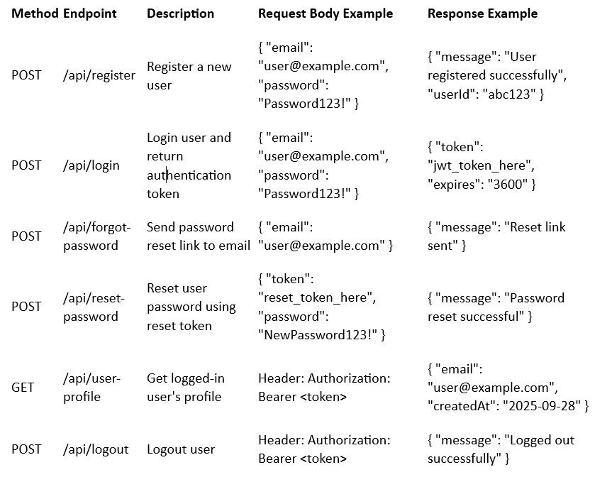
ACCEPTANCE CRITERIA :

Registration

- User must be able to register with a valid email and password.
- Password must meet minimum security requirements (e.g., 8+ characters, uppercase, number, special character).
- Duplicate email registrations must be prevented.
- Confirmation email sent after registration.

Login

- User must be able to log in with valid credentials.
- Invalid credentials return proper error message.
- Successful login returns a JWT token with expiry time.

Password Reset

- User can request a password reset link by email.
- Reset link expires after a set time (e.g., 1 hour).
- User can reset password using valid reset token.
- Confirmation message after password reset.

Security

- Passwords must be hashed in the database.
- Login attempts limited to prevent brute force attacks.
- All endpoints must be protected with HTTPS.
- JWT tokens must be validated for all protected routes.

